Unit 17:

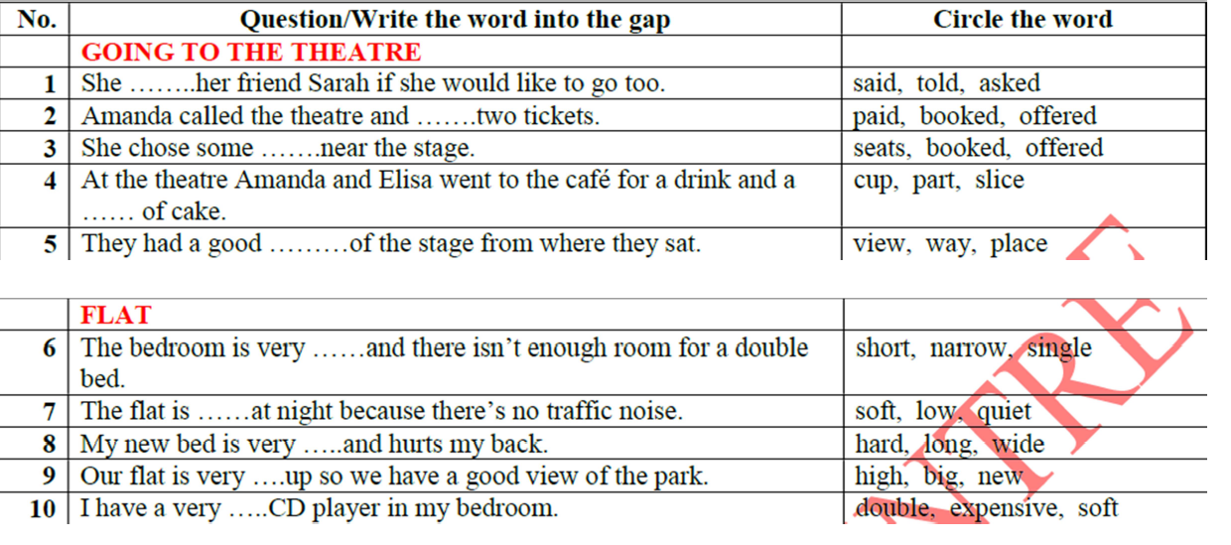

A slice of : mau, lat, mieng …

Say to sb:

Tell sb to Vnd: bao ai lam gi

Tell sb about st: k echo ai nghe ve cai gi

Ask sb to Vnd: bao ai lam gi

Ask sb if …: hoi ai lieu…

Reading part 3_1

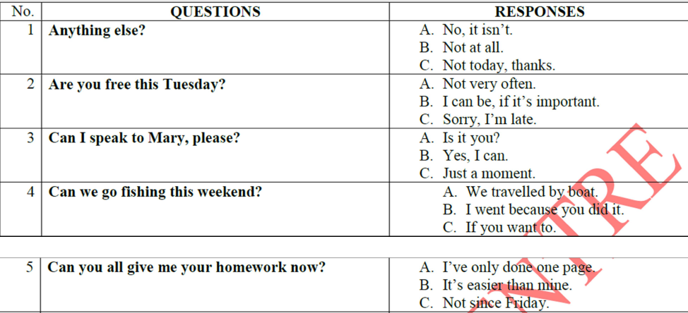

Huong dan phan doc so 3B (16-20).

* Hoan thanh hoi thoai
* Chon p.a de dien vao hoi thoai.
* 2 nguoi: ai noi trc? Ai sau?
* Gach bo Phuong an da lam mau.
* Doc cau dung truoc va cau dung sau cho trong => du doan xem dai y cua cau ve cai gi.
* Doi chieu p.a.
* Viet p.a vao phieu tra loi

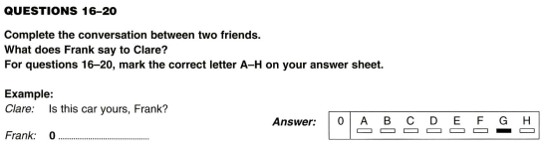

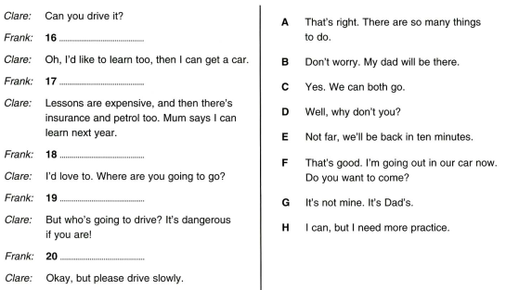

Practice 2

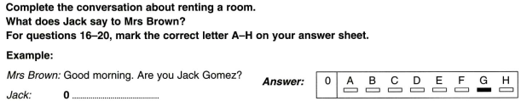

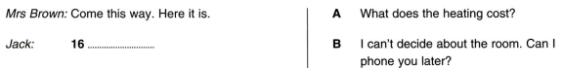

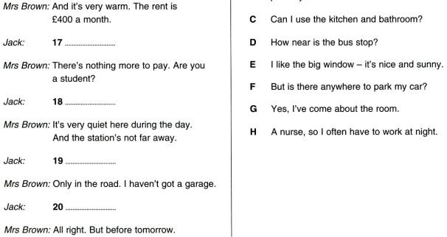

Practice 3:

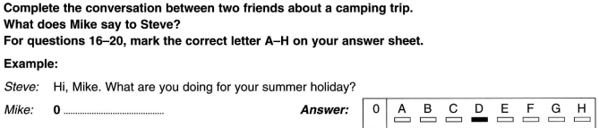

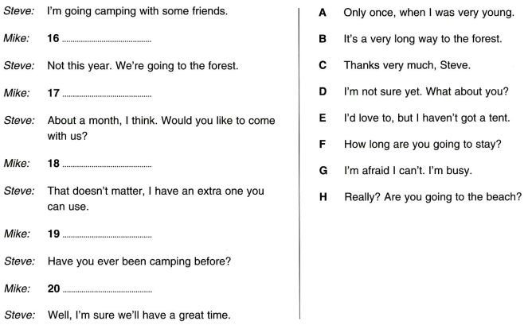

Practice 4





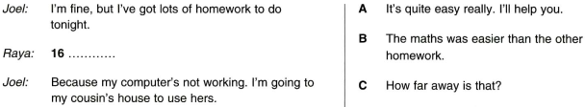

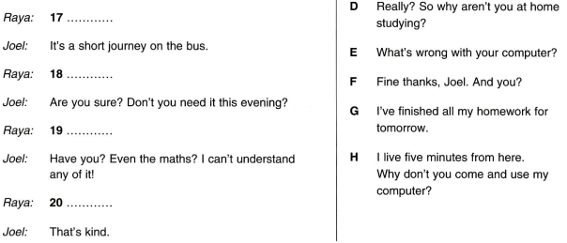

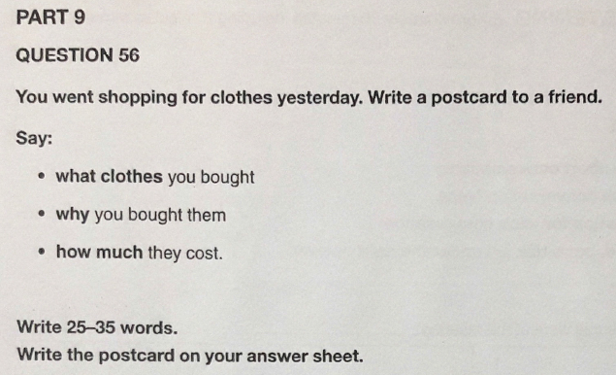

Dear Mike,

I went shopping for clothes yesterday. I bought some jeans. I bought them because they were very cheap. They cost 200.000 vnd. How do you think about them? Write to me soon.

Minh

**Writing part 8:**

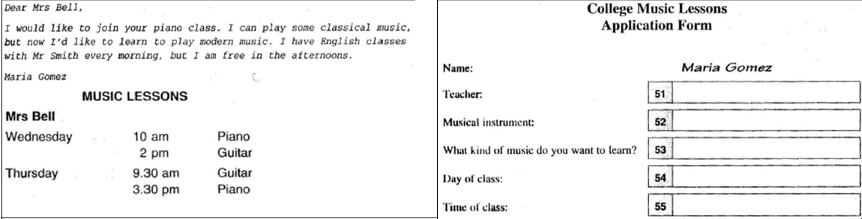

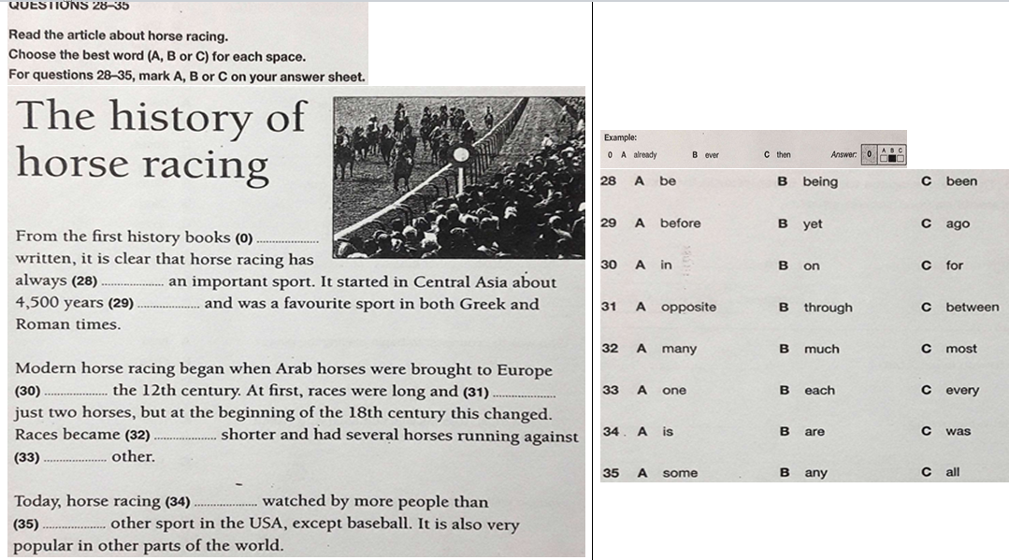

**Listening**

|  |  |
| --- | --- |
| LISTEINING |  |